ASSIGNMENT – 6.2
SHRUTHI ADDAGUDI| 2303A52133 | Batch – 37

Task Description-1 (Classes – Data Validation)
• Prompt AI to generate a Student class with attributes: name roll_no, and marks. Add a method is_pass() that returns whether the student has passed (marks ≥ 40).
Prompt used:
Generate a Student class with attributes name, roll_no, and marks. Add a method is_pass() that returns whether the student has passed (marks ≥ 40).
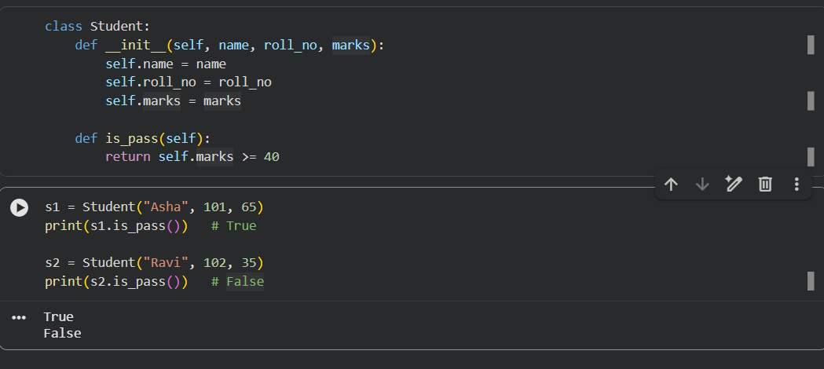
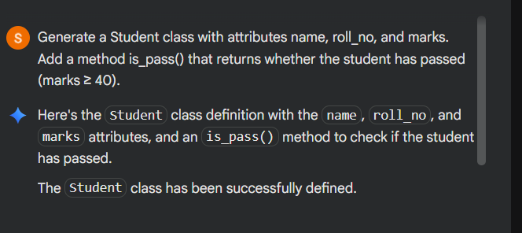
Explanation
- The __init__ constructor initializes student details.
- The is_pass() method checks if marks are greater than or equal to 40.
- Returns True for pass and False for fail.
Analysis
- Code is simple, readable, and correct.
- Validation logic is clearly implemented.
- AI-generated class design follows Python best practices.

Task Description-2 (Loops – Pattern Generation)
Ask AI to generate a function that prints a right-angled triangle star pattern using a for loop. Then regenerate the same pattern
using a while loop.
Prompt used :
Generate a function that prints a right-angled triangle star pattern using a for loop and then using a while loop.
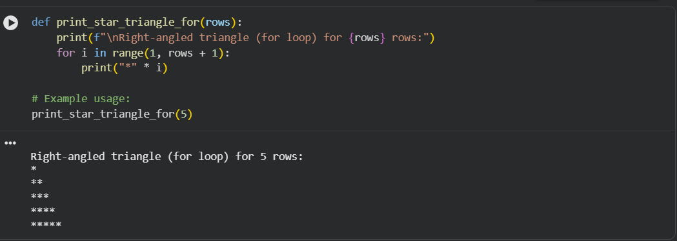
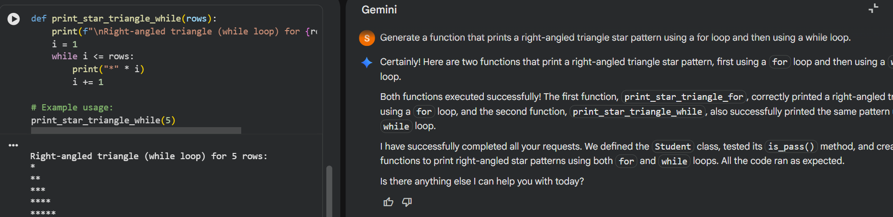

Explanation
- The loop counter controls the number of stars printed.
- Both loops produce identical output with different logic structures.

Analysis
- AI correctly used loop conditions.
- Logical flow is easy to understand.
- Demonstrates equivalent solutions using different looping constructs.

Task Description-3 (Conditional Statements – Number Analysis)
• Ask AI to write a function that checks whether a given number is positive, negative, or zero using if-elif-else. Test the function with multiple inputs.
Prompt used:
Write a function that checks whether a given number is positive, negative, or zero using if-elif-else.
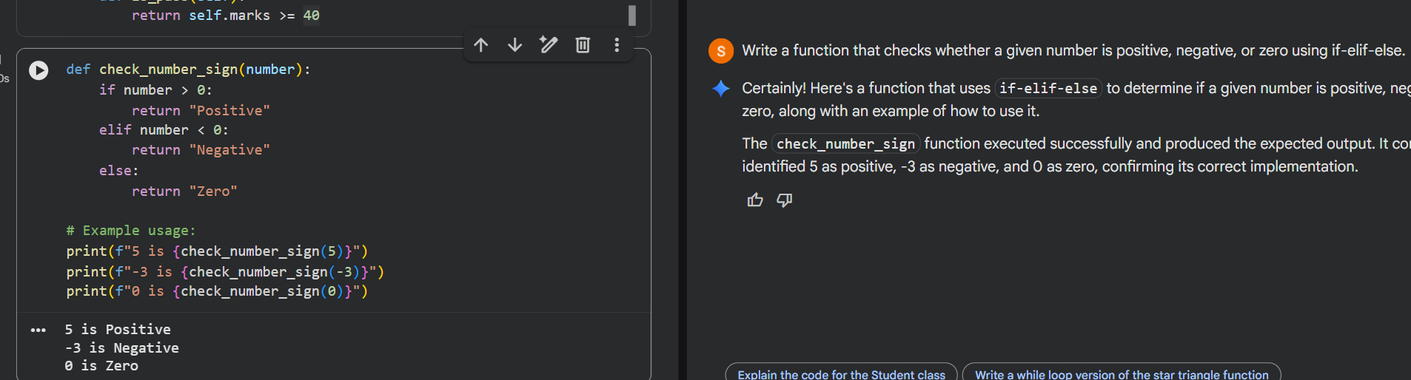

Explanation
- Uses if, elif, and else to classify numbers.
- Covers all possible conditions.

Analysis
- Decision logic is complete and correct.
- AI handled edge case (zero) properly.
- Code is concise and readable.

Task Description-4 (Nested Conditionals)
• Generate a function check_discount(age, is_member) that
determines discount eligibility:
• Age ≥ 60 → Senior discount
• Member → Additional discount
Use nested if statements
Prompt used:
Create a function check_discount(age, is_member) using nested if statements: Age ≥ 60 → Senior discount Member → Additional discount
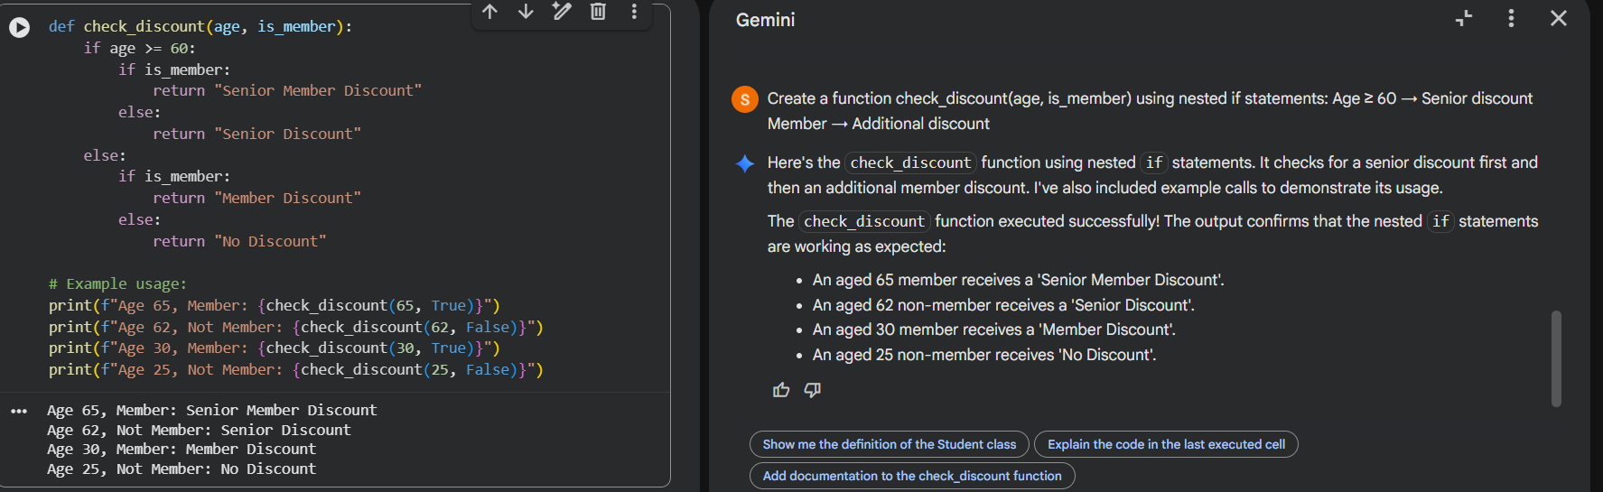
Explanation
- Nested if statements check age first, then membership.
- Clear hierarchical decision flow.

Analysis
- AI correctly implemented nested conditionals.
- Logic is easy to trace and debug.
- Matches real-world discount scenarios.
Task Description-5 (Class – Mathematical Opera)
• Ask AI to create a Circle class with methods to calculate area () and circumference () given the radius.
Prompt used:
Create a Circle class with methods to calculate area and circumference given the radius.
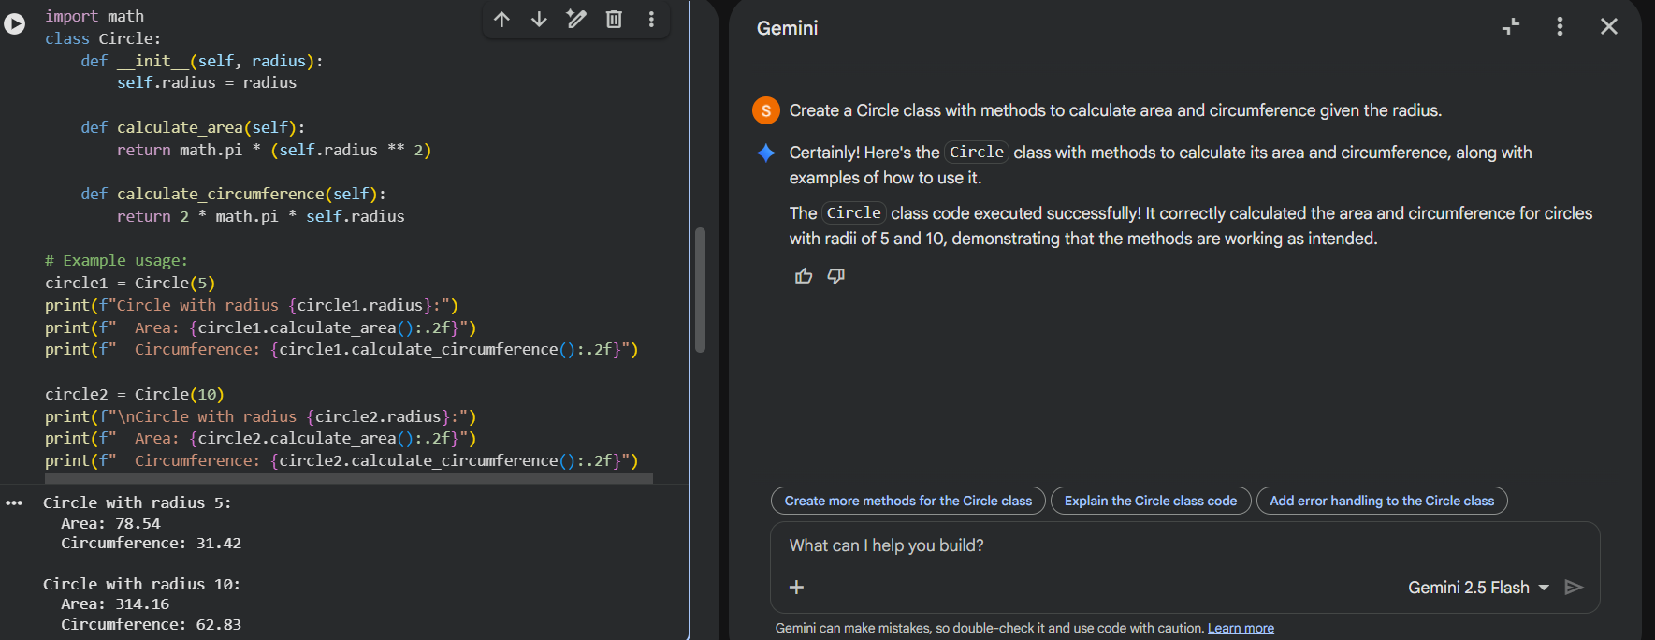
Explanation
- Uses math.pi for accurate calculations.
- Area and circumference formulas are correctly implemented.
- Class design is modular and reusable.

Analysis
- Mathematical logic is accurate.
- Code follows object-oriented principles.
- AI-generated solution is efficient and well-structured.

